CST 415 – Lecture 3
Wilsonville, Fall 2017

ICN 7.1-7.6, CNP 5: Network Layer, IPv4, Addressing and Routing

Network Layer
Layer 3, Network – Moves data in packets from machine to machine and across connected networks, identifies nodes with a network address

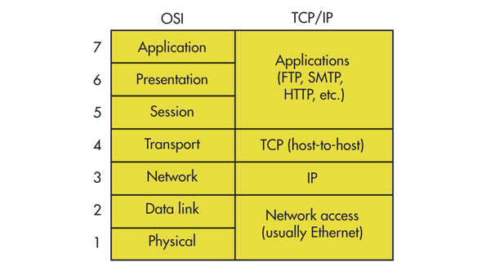

Requires following, independent of underlying LANs (Data link / Physical layers):
Addressing that is unique across the wider network
Routing between and across multiple LANs
Protocol that addresses fragmentation and reassembly of packets

IP stands alone at this layer in today’s internet

IPv4, first developed in 1970’s, standard adopted in 1981
IPv6, protocol publised in 1998, to be mass deployed in 2012 (fyi, didn’t happen)

IPv4
IP is a protocol for routing and addressing across various LANs

Meant to be flexible and allow data to be delivered anywhere,
as long as each router correctly implements the protocol

The design of IP version 4 was based on the following assumptions:
- IP should provide an unreliable connectionless service
Higher layers, like TCP provides reliability when required by the application
- IP operates with the datagram transmission mode
- IP addresses have a ﬁxed size of 32 bits
- IP must be usable above different types of datalink layers
- IP hosts exchange variable length packets
- CN pg. 141

IP packets are carried on underlying LAN, e.g. Ethernet, with content possibly spread across multiple frames
​
IP Packet header:
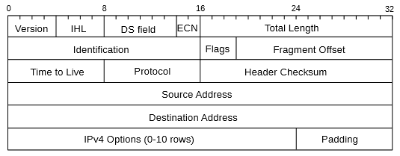
- ICN pg. 156

Version = 4 (0100)
IHL = header length (minimum 20 bytes, maximum 80 bytes)
DS / ECN = options for differentiated service and congestion control
Total Length = length of full packet, including header and data
Identification / Flags / Fragment Offset = used for fragmentation control
Time to Live = decremented at each router, prevents infinite loops!
Protocol = Transport protocol at layer 4, e.g. TCP = 6, UDP = 17
Header Checksum = ensures header is not corrupted
Source and Destination Address = IP address for src/dest
IPv4 Options / Padding = used for various routing / multicast / broadcast options

IPV4 Addressing
IPv4 addresses are 32-bit
IPv6 addresses are 128-bit

IPv4 Address structure: A.B.C.D, where each are one byte

Special addresses:
10.x.x.x – private addresses
127.0.0.1 – loopback address, “localhost”

NAT – Network Address Translation, uses…
External IP + External Port = Internal IP + Internal Port

Interfaces have addresses, not hosts
Most hosts have more than one interface, multi-homed, e.g. Ethernet vs. Wifi
VPN – Virtual Private Network, implemented as an interface

IPV4 Routing
Routing occurs at boundaries between LANs

Routers include lookup tables that help decide where to next send a packet

Must adjust the header as needed and update the header checksum
For example, Time to live decremented at each router

Subnets break up a full IP network into parts, each with their own address domain
Routers exist at each boundary between the subnets
Use subnet masks to divide off parts of network and identify what's inside vs. outside
Each host will have its IP address, subnet mask and router

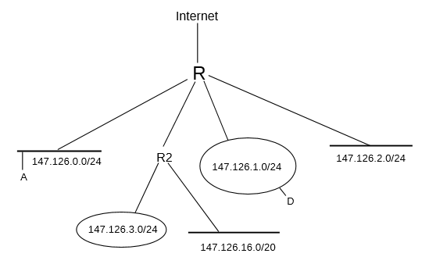
- ICN pg. 164

Router R has address 147.126.0.0/16, everything behind it has address 147.126.x.x
The network is sub-divided into subnets…
147.126.0.0/24, addresses 147.126.0.x, subnet mask 255.255.255.0
147.126.1.0/24, addresses 147.126.1.x, subnet mask 255.255.255.0
147.126.2.0/24, addresses 147.126.2.x, subnet mask 255.255.255.0
147.126.3.0/24, addresses 147.126.3.x, subnet mask 255.255.255.0
Router R2 also has another part of the network behind it with subnet…
147.126.16.0/20, addresses 147.126.32.x through 147.126.63.x,
enabled by subnet mask 255.255.240.0

"Switch when you can, route when you must"
- ICN pg. 198

IPV4 Fragmentation
Fragmentation occurs when an IP packet is too large for a local LAN it has to traverse
MTU – Max Transmission Unit, largest size frame that can be delivered on a LAN

Reassembly requires knowing packets belong together and in what order

Per-link Reassembly – fragments wait at end of each a layer 2 link
Path Reassembly – fragments wait at layer 3 network destination
Path is used in IP because fragments could go by different routes

Identification, Flags and Fragment Offset used in IP header
Identification uniquely identifies packet
Flags are set to indicate intermediate vs. final fragment
Fragment Offset is location of the fragment in the total packet's data bytes

At the final network destination, packet is reassembled in a buffer
Each fragment is placed in its proper location by offset (Fragment Offset)
Separate buffer kept for each unique packet (Identification)
When the buffer is complete (packet fully reassembled), packet is delivered to layer 4

Note: TCP uses MTU discovery to avoid fragmentation during routing, it fragments before sending through IP

Example (ICN pg. 160):
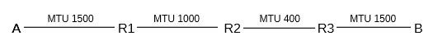
1500 byte packet sent from A to B, including 20 bytes of header, 1480 bytes of data

In class: How is packet fragmented and reassembled by each router?

From A to R1… all 1500 bytes of packet are kept together
From R1 to R2… split into 2 fragments…
Frag1, 20 byte header, 980 byte data
Frag2, 20 byte header, 500 byte data
From R2 to R3… split into 3+2 = 5 total fragments
Frag1.1, 20 bytes header, 380 byte data
Frag1.2, 20 bytes header, 380 byte data
Frag1.3, 20 bytes header, 220 byte data
Frag2.1, 20 bytes header, 380 byte data
Frag2.3, 20 bytes header, 120 byte data
From R3 to B… transmit all 5 fragments as they are
At B… reassemble the 5 fragments into the original 1480 bytes of data

